1. **CFY Introduction to Networking Lab Exam [80 Minutes]**

| **Student Name** | **Samuel Asuoha** | **Lab Instructor** | **Kevin Conway** |
| --- | --- | --- | --- |
| **Student ID** | **C00305107** | **Final Marks (/100)** |  |
| **Student Group** |  |  |  |
| **Date/Time** | **27/11/2024** |  |  |

**Instructions:**

* **Duration: 80 minutes**
* Use Packet Tracer
* Label all devices clearly & put your name/ID in PT file
* Save your configuration

1. **Topology**

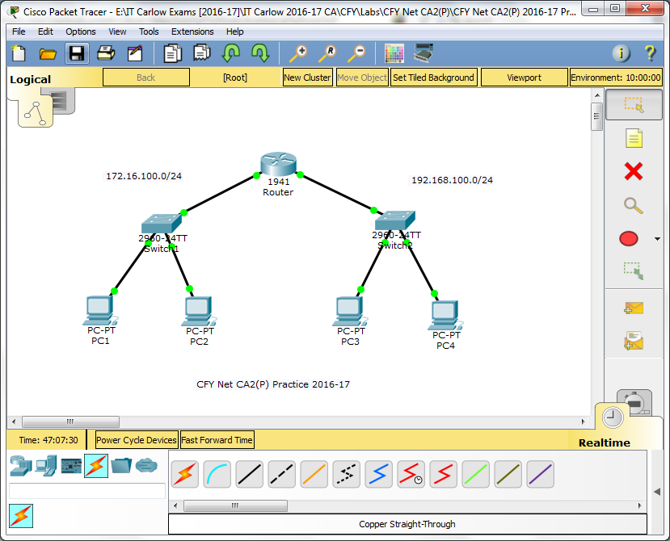

1. **Addressing Table**

| **Device** | **Interface** | **Address** | **Subnet Mask** | **Default Gateway** |
| --- | --- | --- | --- | --- |
| Router | G0/0 | 172.16.100.1 | 255.255.255.0 | N/A |
| G0/1 | 192.168.100.1 | 255.255.255.0 | N/A |
| Switch1 | VLAN 1 | 172.16.100.2 | 255.255.255.0 |  |
| Switch2 | VLAN 1 | 192.168.100.252 | 255.255.255.0 |  |
| PC1 | NIC | 172.16.100.11 | 255.255.255.0 |  |
| PC2 | NIC | 172.16.100.12 | 255.255.255.0 |  |
| PC3 | NIC | 192.168.100.12 | 255.255.255.0 |  |
| PC4 | NIC | 192.168.100.13 | 255.255.255.0 |  |

1. **Passwords**

| **Device** | **Security Type** | **Password** |
| --- | --- | --- |
| Switch1, Switch2, Router | All | **cisco/cisco1** |

1. **Assessment Objectives**

**Part 1: Complete Addressing Table & Cable Network (20 points)**

**Part 2: Configure Switch (30 points)**

**Configure switch name & disable domain lookup**

**Secure access to all configuration lines of the switch**

**Secure access to the device configurations of the switch using the encrypted password**

**Ensure that all plain text passwords on the switch are encrypted.**

**Configure an appropriate banner on the switch**

**Configure addressing for all devices according to the Addressing Table. Most values are provided in the table, others you must determine**

**Document interfaces with descriptions on the switch virtual interface**

**Part 3: Configure Router (25 points)**

**Configure addressing for all devices according to the Addressing Table**

**Secure access to all configuration lines of the router**

**Secure access to the device configurations of the router using the encrypted password**

**Ensure that all plain text passwords on the router are encrypted.**

**Configure an appropriate banner on the router**

**Document interfaces with descriptions on the router interfaces**

**Part 4: Configure PCs (10 points)**

**Configure addressing for PCs according to the Addressing Table. Most values are provided in the table, others you must determine**

**Part 5: Test Network (15 points)**

**Verify connectivity between all devices. All devices should be able to ping all of the other devices.**

**Troubleshoot any connectivity problems.**

1. **Scenario**

In this Skills Assessment (SA) you will configure the devices in a small network. You must configure router, switches and PCs to support IPv4 connectivity. You will configure security on the devices. You will test and document the network using common CLI commands. Finally, you will save the router configuration to NVRAM.

1. **Required Resources**

* 1 Router (Cisco 1941)
* 2 Switches (Cisco 2960)
* 4 PCs
* Console cable to configure the Cisco IOS devices via the console ports
* Ethernet cables as shown in the topology

1. **Complete Addressing Table & Cable Network**

* Complete the Addressing Table:

**Total points: 12 = 6x2**

| **Device** | **Interface** | **Address** | **Subnet Mask** | **Default Gateway** |
| --- | --- | --- | --- | --- |
| Router | G0/0 | 172.16.100.1 | 255.255.255.0 | N/A |
| G0/1 | 192.168.100.1 | 255.255.255.0 | N/A |
| Switch1 | VLAN 1 | 172.16.100.2 | 255.255.255.0 | N/A |
| Switch2 | VLAN 1 | 192.168.100.252 | 255.255.255.0 | N/A |
| PC1 | NIC | 172.16.100.11 | 255.255.255.0 | 172.16.100.1 |
| PC2 | NIC | 172.16.100.12 | 255.255.255.0 | 172.16.100.1 |
| PC3 | NIC | 192.168.100.12 | 255.255.255.0 | 192.168.100.1 |
| PC4 | NIC | 192.168.100.13 | 255.255.255.0 | 192.168.100.1 |

* Cable the network:

**Total points: 8 = (Router=2, Switches/PCs=6x1)**

**Instructor Sign-off Part 1: _____________**

**Part 2: Configure the Switch**

**Total points: 30**

* Configure **both** switches
* Configure switch with name given in addressing table & disable domain lookup
* Secure access to all configuration lines of the switch
* Secure access to the device configurations of the switch using the encrypted password
* Ensure that all plain text passwords on the switch are encrypted.
* Configure an appropriate banner on the switch
* Configure addressing for all devices according to the Addressing Table. Most values are provided in the table, others you must determine
* Document interfaces with descriptions on the switch virtual interface

| **Task** | **Specification** | **IOS Commands** | **Points (30)** |
| --- | --- | --- | --- |
| Config switch name | S1/S2 | Switch>en  Switch#config t  Switch(config)# hostname Switch1  (same commands for Switch2, except hostname which is named as Switch2) | (3 points) |
| Disable DNS | S1/S2 | no ip domain-lookup | (3 points) |
| Secure access to switch | S1/S2 | Switch1(config)# enable secret cisco  Switch1(config)# line console 0  Switch1(config-line)# password cisco1  Switch1(config-line)# login  Switch1(config-line)# exit  Switch1(config)# line vty 0 4  Switch1(config-line)# password cisco1  Switch1(config-line)# login  Switch1(config-line)# exit  (Same commands for Switch2) | (14 points) |
| Encrypt text password | S1/S2 | service password-encryption | (3 points) |
| Config banner | S1/S2 | banner motd #Warning! Authorized access only# | (2 points) |
| Config switch interface | S1 | Switch1(config)# interface vlan 1  Switch1(config-if)# ip address 172.16.100.2 255.255.255.0  Switch1(config-if)# no shutdown | (3 points) |
| Config switch interface | S2 | Switch2(config)# interface vlan 1  Switch2(config-if)# ip address 192.168.100.252 255.255.255.0  Switch2(config-if)# no shutdown | (3 points) |
| Document switch interfaces | S1/S2 | description Management Interface | (3 points) |

**Points: _______ of 30**

**Part 3: Configure the Router**

**Total points: 25**

* Configure addressing for router according to the Addressing Table
* Document interfaces with descriptions on the router interfaces

| **Task** | **Specification** | **IOS Commands** | **Points (25)** |
| --- | --- | --- | --- |
| Config router interface | Router | **Router>en**  **Router#config t**  **Router(config)#interface g0/0**  **Router(config-if)# ip address 172.16.100.1 255.255.255.0**  **Router(config-if)#description Link to Switch1**  **Router(config-if)#no shutdown** | (7 points) |
| Config router interface | Router | **Router(config)#interface g0/1**  **Router(config-if)#ip address 192.168.100.1 255.255.255.0**  **Router(config-if)#description Link to Switch2**  **Router(config-if)#no shutdown** | (7 points) |
| Secure access to router | Router | **Router(config)#enable secret cisco**  **Router(config)#line console 0**  **Router(config-line)#password cisco1**  **Router(config-line)#login**  **Router(config-line)#exit**  **Router(config)#line vty 0 4**  **Router(config-line)#password cisco1**  **Router(config-line)#login**  **Router(config-line)#exit** | (5 points) |
| Encrypt text password | Router | **Router(config)#service password-encryption** | (3 points) |
| Config banner | Router | **Router(config)#banner motd #Warning! Authorized Access Only!#** | (3 points) |

**Points: _______ of 25**

**Part 4: Configure the PCs**

**Total points: 10 = 4x2.5**

* Configure addressing for PCs according to the Addressing Table. Most values are provided in the table, others you must determine

**Points: _________ of 10**

| **Device** | **Type** | **IP** | **SNM** | **Default G/W** |
| --- | --- | --- | --- | --- |
| PC1 | NIC | 172.16.100.11 | 255.255.255.0 | 172.16.100.1 |
| PC2 | NIC | 172.16.100.12 | 255.255.255.0 | 172.16.100.1 |
| PC3 | NIC | 192.168.100.12 | 255.255.255.0 | 192.168.100.1 |
| PC4 | NIC | 192.168.100.13 | 255.255.255.0 | 192.168.100.1 |

**Part 5: Test Connectivity**

**Total points: 15 = 3*5**

* **Verify connectivity between all devices. All devices should be able to ping all of the other devices.**
* **Troubleshoot any connectivity problems.**

| **From** | **To** | **Command** | **Results** | **Points** |
| --- | --- | --- | --- | --- |
| PC-1 | S1 Management Address | ping 172.16.100.2 | Reply from 172.16.100.2: bytes=32 time<1ms TTL=255  Reply from 172.16.100.2: bytes=32 time<1ms TTL=255  Reply from 172.16.100.2: bytes=32 time<1ms TTL=255  Reply from 172.16.100.2: bytes=32 time<1ms TTL=255  Ping statistics for 172.16.100.2:  Packets: Sent = 4, Received = 4, Lost = 0 (0% loss),  Approximate round trip times in milli-seconds:  Minimum = 0ms, Maximum = 0ms, Average = 0ms | (5 points) |
| PC-1 | PC-2 | ping 172.16.100.12 | Reply from 172.16.100.12: bytes=32 time<1ms TTL=128  Reply from 172.16.100.12: bytes=32 time<1ms TTL=128  Reply from 172.16.100.12: bytes=32 time<1ms TTL=128  Reply from 172.16.100.12: bytes=32 time<1ms TTL=128  Ping statistics for 172.16.100.12:  Packets: Sent = 4, Received = 4, Lost = 0 (0% loss),  Approximate round trip times in milli-seconds:  Minimum = 0ms, Maximum = 0ms, Average = 0ms | (5 points) |
| PC-3 | PC-2 | ping 172.16.100.12 | Reply from 172.16.100.12: bytes=32 time<1ms TTL=127  Reply from 172.16.100.12: bytes=32 time<1ms TTL=127  Reply from 172.16.100.12: bytes=32 time<1ms TTL=127  Reply from 172.16.100.12: bytes=32 time<1ms TTL=127  Ping statistics for 172.16.100.12:  Packets: Sent = 4, Received = 4, Lost = 0 (0% loss),  Approximate round trip times in milli-seconds:  Minimum = 0ms, Maximum = 0ms, Average = 0ms | (5 points) |

**Points: _____ of 15**

**Instructor Check/Sign-off: __________________________________________________________**